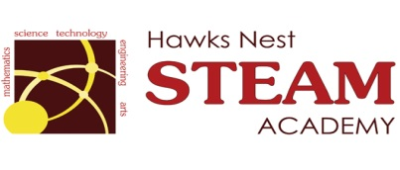 School Counseling Program Newsletter
Shandrai Silva, School Counselor | August/September 2017

Counselor Message  Welcome to the 2017-18 school year! I hope each of you had a relaxing and fun-filled summer with your family and friends. As we begin another school year, I also hope each of you are excited and looking forward to another great year at Hawks Nest STEAM Academy. I know I am!  This year, the school counseling program hopes to build on the lessons, activities and initiatives implemented last school year. I look forward to meeting with students, school service projects and activities. Please feel free to share any ideas you may have regarding the school counseling program.  ____________________________  How to see the school counselor  Classroom guidance classes, small group counseling and individual counseling by self -referral, parent referral, teacher referral, administrator referral or counselor initiated.  Feel free to contact school counselor, Shandrai Silva @ sosilva@gaston.k12.nc.us and/or 704-866-8467.   | Home of the Hawks  Happenings @ the Nest  *International Dot Day*  Join us in celebrating International Dot Day, a global celebration of creativity, courage and collaboration on Friday, September 15th. Birthed from The Dot by Peter Reynolds, International Dot Day encourages students to trust their own abilities by being brave enough to “make their mark” and embark on a journey of creativity, confidence and self-discovery. Hawks Nest will make its mark by participating in a schoolwide service project the week of September 11th. On September 15th, everyone is encouraged to wear dots on International Dot Day!  http://www.thedotclub.org/dotday/get-started  *International Day of Peace  September 21st – wear white | Character Education  “We’re Soaring with Good Character”  _______________________________ The character trait of the month is Responsibility. Responsibility means taking care of your duties; answering for your actions; being accountable and trustworthy. Students will learn more about responsibility through morning announcements and classroom activities.  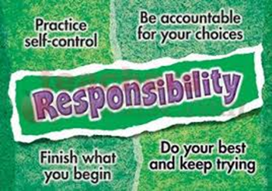  “Intelligence plus character-  that is the goal of true education.”  Dr. Martin L. King, Jr.  _____________________________________  